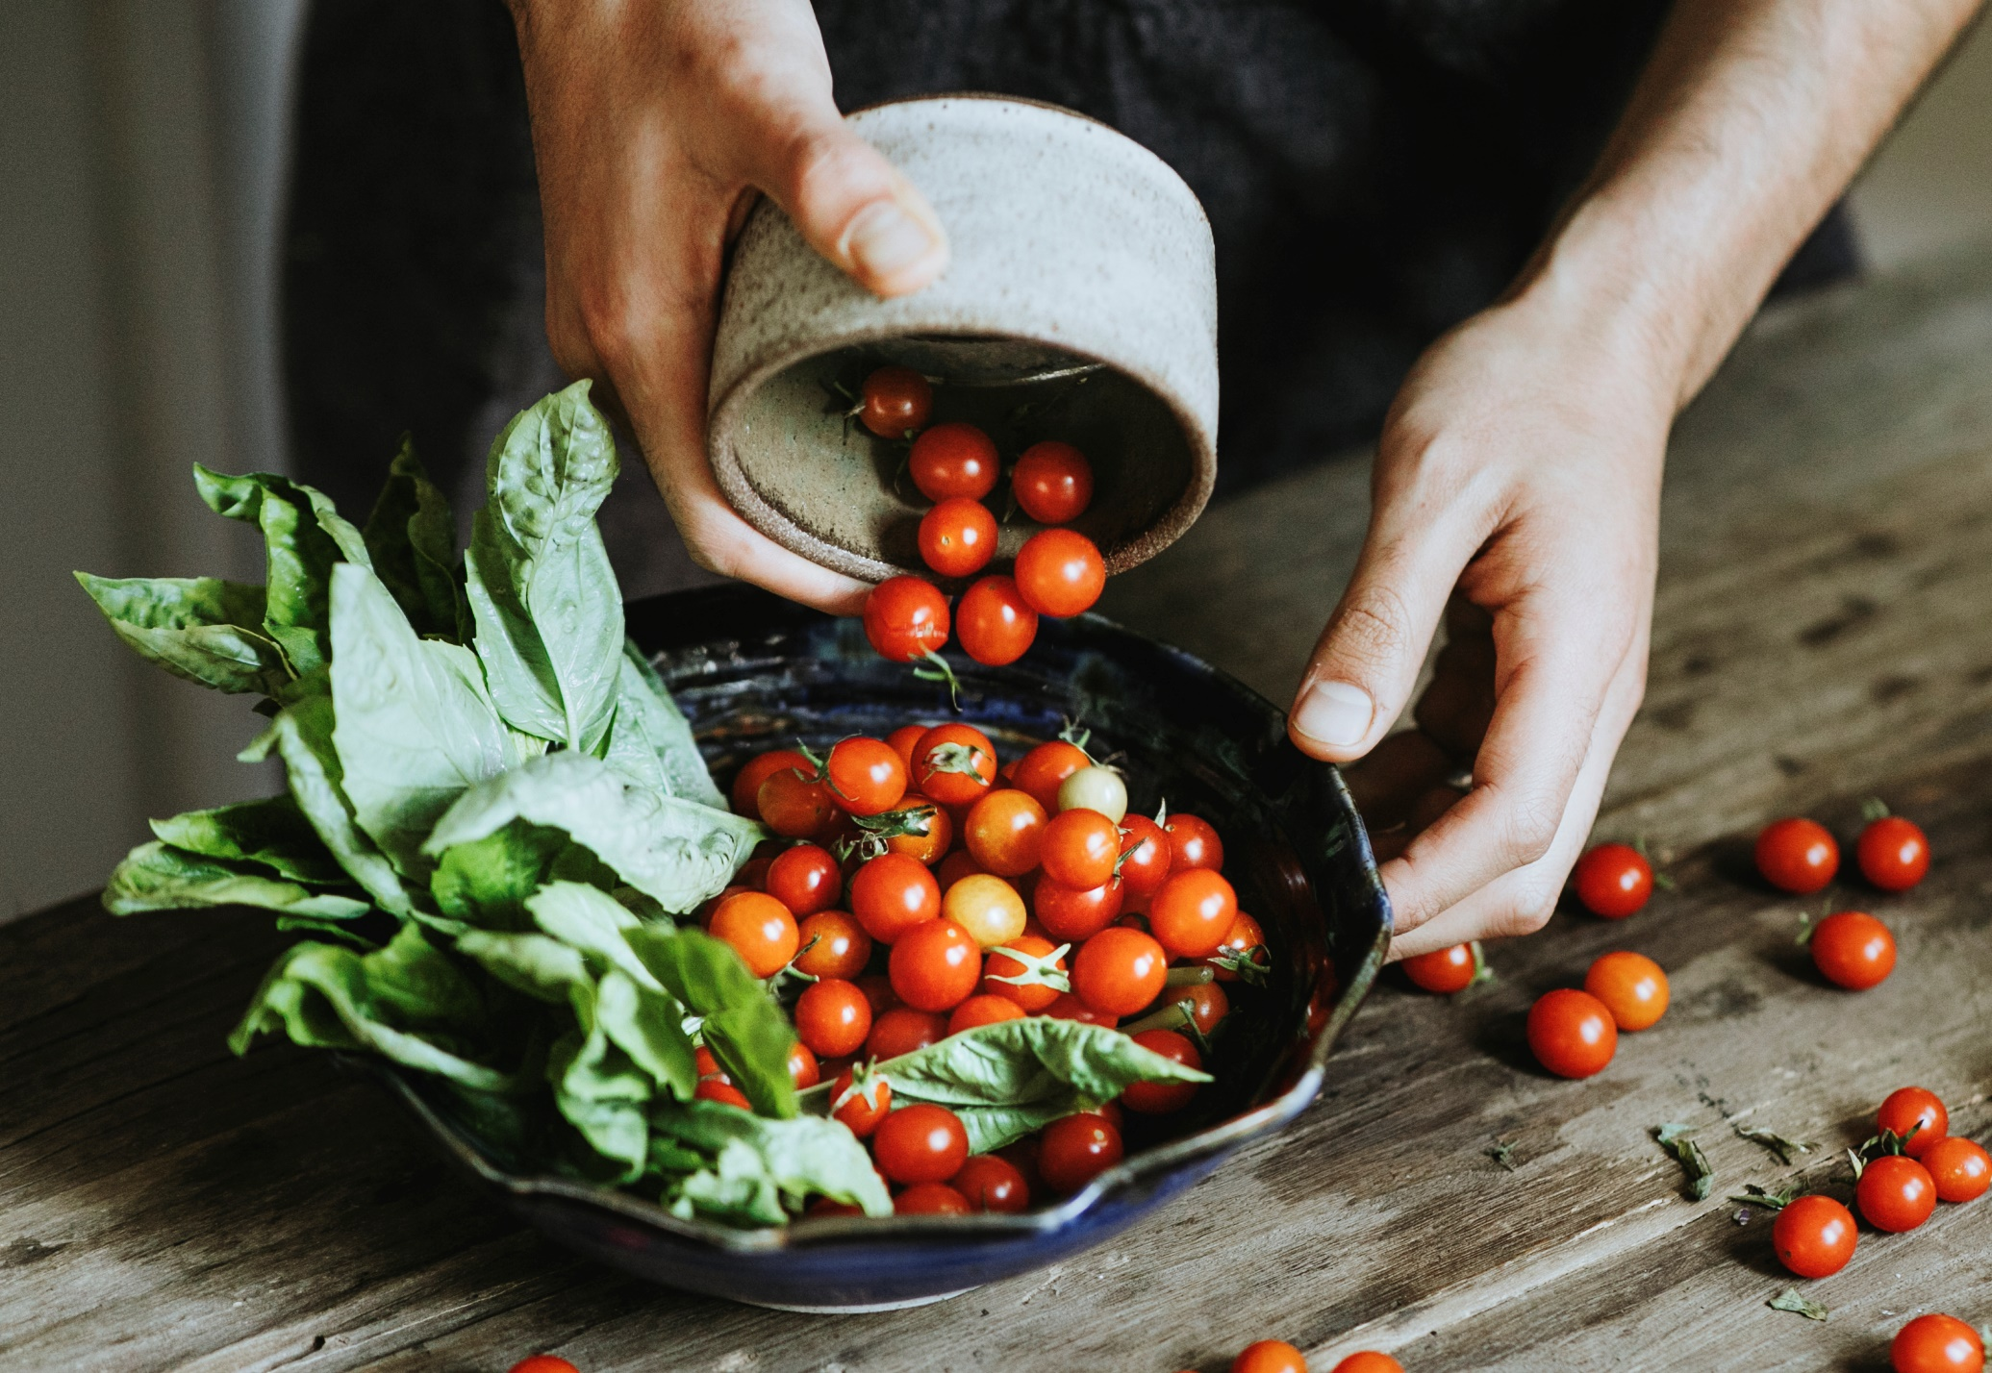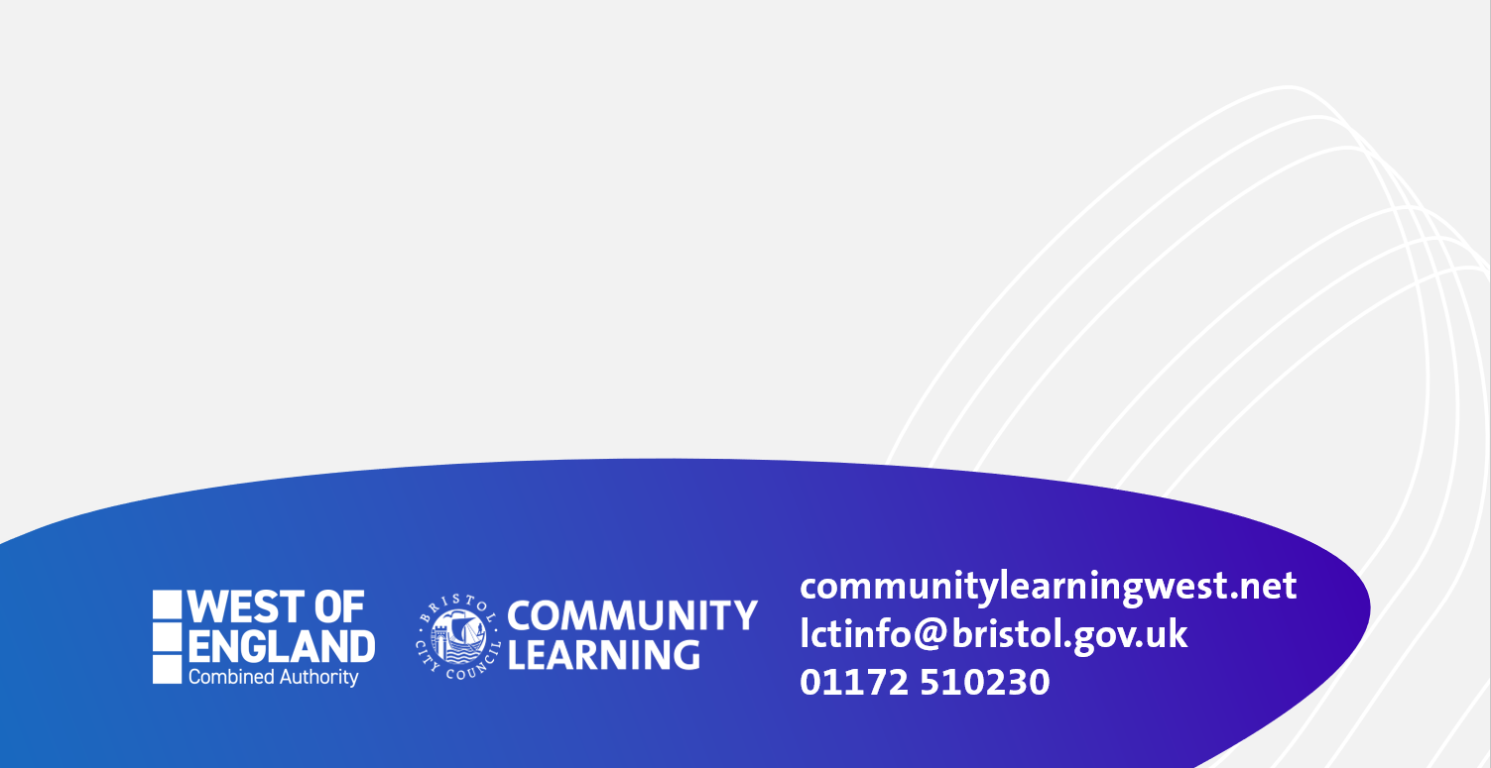

**10.00 until 12.00 Wednesdays**

**STARTS 3rd February online**

**A course that looks at the food we eat and explores healthy and nutritional ways we can prepare food without costing too much!**

**Lots of great recipe ideas and join in cooking together each week.**

**Ingredients can be supplied.**

**We can help you get online too.**

**Text or phone Helen 07760990855**

**Course for adults 19+ with low or no qualifications**

**You Are What You Eat!**

**Free Course**